
CRM Project
FRD (FUNCTIONAL REQUIREMENTS DOCUMENTATION)
Version 1.0
CRM System for ISEET Digital Transformation

Date: 5/4/2026
presented by: Hamzah Ghnimat

position: BA

Table of Contents

TITLE PAGE……………………………………………………………………1
INTRODUCTION………………………………………………………………3
DEFINITIONS………………………………………………………………….3
SCOPE…………………………………………………………………………..4
1. functional REQUIREMENTS ……………………………………...…4
1.1 Overview……………………………………………………………………………….?
1.2 Detailed Functional Requirements…………………………………...........................?
2. UML DIAGRAM………………..……………………………………………7
2.1 use case ………………………………………………………………………………..?
2.2 activity diagram……………………………………………………….........................?
2.3 Architecture diagram…………………………………………………………………?
ACCESS LEVELS……………………………………………………………..12
4. BUSINESS PROCESSES & WORKFLOWS…………………………..….13
4.1 Log in…………………………………………………………………........................?
4.2 reports……………………………………………………………….………………..?
4.3 consultations……………………………………………………….…………………?
4.4 Job opportunity………………………………….…………………….......................?

INTRODUCTION
This document provides a detailed description of all the functions and features that will be implemented in the CRM system.

The CRM system for ISEET is designed to improve customer relationships, organize client information in one place, and maintain a complete communication record. The system will also help track customers, improve sales, and ensure a user-friendly and flexible experience for all users. In addition, the system will support the management team by providing simple reports and real-time updates on business opportunities. It will also allow employees to communicate with clients directly through the system, ensuring that all interactions are recorded and easily accessible at any time.

DEFINITIONS

- Admin: who is responsible for all system.

- Employees: who organizes the CRM system.

- User/Customer: who visits the company website and wants a service.

- Notification: An automatic alert that tells users or employees about any important update or action needed.
- Opportunity: A potential deal with a client that is tracked until it is either won or lost.
- Report: A summary that shows what happened in the system to help make better decisions.

IN-SCOPE AND OUT-OF-SCOPE
The ISEET CRM project focuses on developing a dual-platform system: a customer-facing website and an internal management portal. In-scope features include automated lead generation, a centralized client database, and specialized dashboards for managers and employees to track meetings, projects, and communication history. The system will integrate an AI-driven module for sales forecasting and automated notifications to streamline workflow. Out-of-scope items include payment processing, mobile application development, and full HR management, ensuring the project remains focused on enhancing client relationships and sales efficiency.

This section provides an overview from the perspectives of the client, manager, and employee.

Functional Requirements

General Overview

Client Perspective
When a customer visits the website, the system displays a login button, a video explaining the consulting firm's services, and a section dedicated to available job opportunities, all within the ISEET user interface.

Manager and Employee Perspective
When a manager or employee logs into the Customer Relationship Management (CRM) website, the system will display a user interface containing their username and password for accessing the site. For both employees and managers, a page will be displayed for each customer contact, including all login information and other relevant details such as meeting notes and times. The manager will also be provided with any reports from employees or clients.

DETAILED FUNCTIONAL REQUIREMENTS

When a client opens the ISEET website, the system must create a "talk to us" button at the top of the page. Clicking this button will display a user interface showing the contact’s name, organization, sector, country, email address, and phone number.

Clicking the "Submit" button in the same user interface will allow us to receive all this information and send it to the CRM system.

The system must create a page for each customer on the CRM website, sending all login information from the ISEET system to each customer's page. When a page is clicked, all information related to that customer is displayed.

The system must create a button at the top of the ISEET website labeled "Consultations." When clicked, the client will see a video explaining all of ISEET's services and a section to schedule a meeting if they wish to consult. The appointment will then be sent to their CRM page.

Before any consulting session, the employee will receive a notification on the client's profile in the CRM showing the scheduled meeting date and time. After the consulting session, all meeting notes, details, and client interests will be recorded and saved automatically on the client's profile.

When the manager and employee log in to the CRM system, they will be presented with a login interface (username and password).

When a manager logs into the Customer Relationship Management system, all customer information pages will be displayed for them. The first section will contain all employee reports based on customer feedback, while the second section allows them to schedule meetings with customers based on employee input. The third section is used to explain all of the manager's projects.

When an employee logs into the CRM system, all their customer information pages will appear, and they will have a section that allows them to send any reports or information about their meetings with customers to the manager, and if the manager has a meeting scheduled.

The system must allow the manager or employee to be able to access the customer page and view a list of all their information. When an employee clicks on email, the system shall create a small page. When the employee writes a message to the customer, this message is taken and sent to the email program. When the customer replies, we want to take their response and add it to the small page to store all their feedback.

The system must add all feedback, interests, and communication history to the customer profile section to understand their needs and interests.

The system must create a section entitled "Job Opportunities" at the top of the ISEET website page, to display all job opportunities and any benefits related to the projects we carry out, and in general all projects carried out with any company.

The system must create a section that appears to the manager when they log into the CRM system. This section should explain all sales forecasts generated by artificial intelligence. We will provide the AI with the number of contacts with the company, response times, all comments, and preferred services — all from the client profile page — as well as showing the percentage of each client who benefits from our services. We also want to create a button to share this section with employees via email or WhatsApp.

The system must create a "Job Opportunities" button so that employees can add job postings.

UML DIAGRAM

Use case

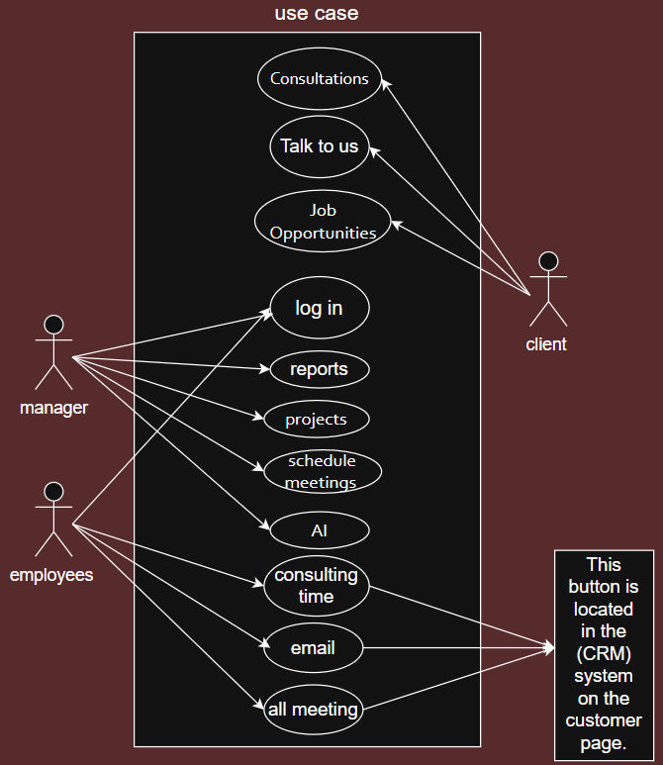

This scenario aims to illustrate all stages of the workflow, from manager to client to employee. Expected outcome: A clearer view of all use cases to determine the most suitable services for each individual.

Activity diagram (user)

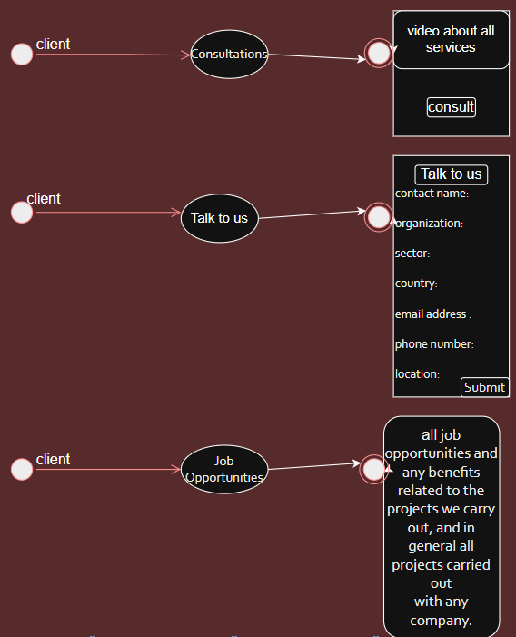

This example aims to present the client with three buttons: "Consultation," "Talk to Us," and "Job Opportunities." Clicking the "Consultation" button displays a video and another "Consultation" button. Clicking the "Contact Us" button displays a list of information. Clicking the "Job Opportunities" button displays all available job opportunities, which should be shown in the "Coordination" section for each job. Expected Outcome: The system gathers all the necessary information and assists the client should they wish to consult or receive a job offer.

Activity diagram (Admin)

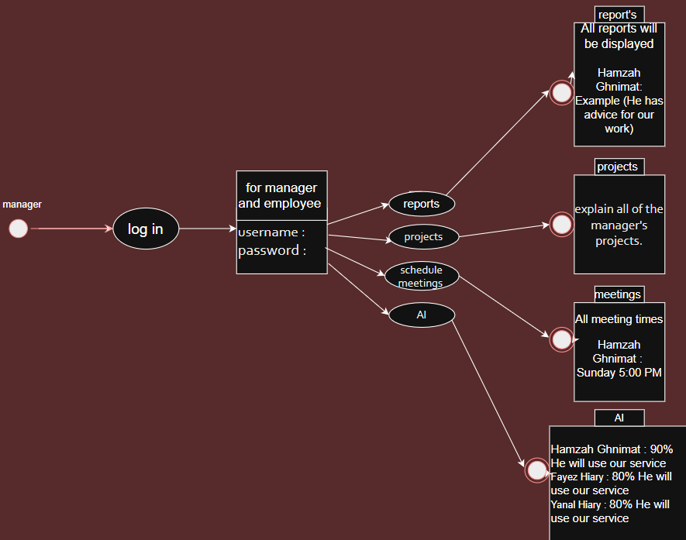

This example purpose to showcase all system features to the manager upon login. Upon clicking the login button, the manager will be prompted to enter their username and password, and four buttons will appear: "Reports," "Projects," "Schedule Meetings," and "Artificial Intelligence." Clicking "Reports" should display all reports from employees and clients. Clicking "Projects" should display all previously managed projects. Clicking "Schedule Meetings" should indicate if the manager has a scheduled meeting. Clicking "Artificial Intelligence" should display the percentage of clients who will utilize our services in the future.

Expected Outcome: Simplified system management for the manager, helping them manage and organize all clients.

Activity diagram (employees)

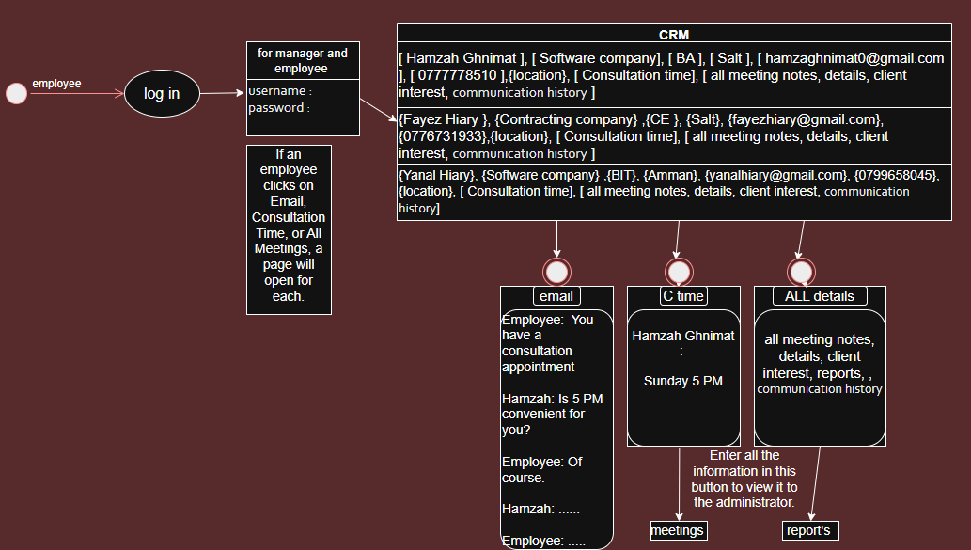

The purpose of this scenario is to display the employee login page. When the employee enters their credentials, the system displays all client profiles. Clicking on any profile opens all client data, along with four buttons: "Email," "Consultation," "Location," and "All Meetings". Expected Outcome: The employee will have access to all client information, as well as four buttons that facilitate sending messages, writing notes, and more.

Architecture diagram

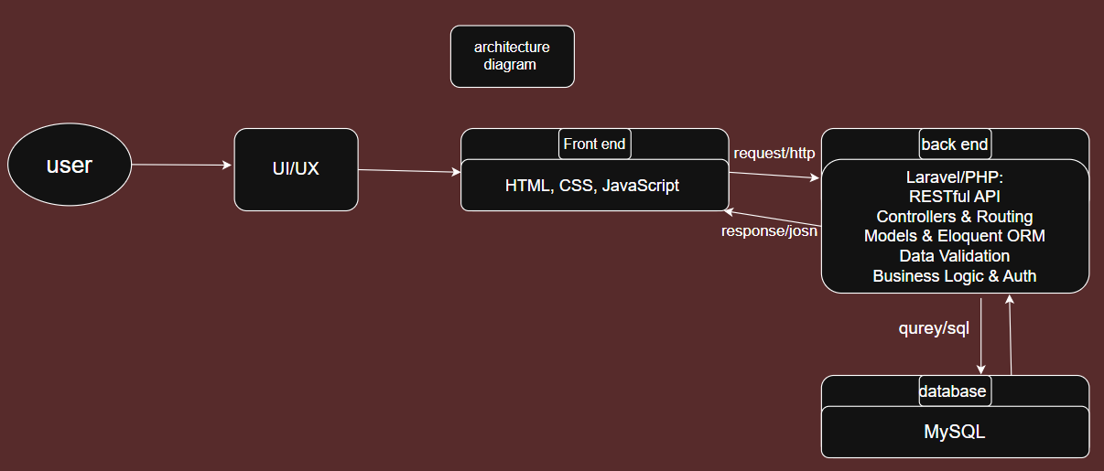
Back-end Layer:
- Develop server-side functionality using Laravel/PHP.
- Implement API endpoints for data handling.
Front-end Layer:
- Build the user interface with HTML, CSS, and JavaScript.
- Design user experience and UI interactions.
System Integration:
- Connect front-end with back-end via HTTP requests.
- Exchange data using JSON responses.
Database Layer:
- Manage data storage using MySQL.
- Write and execute SQL queries for data retrieval and manipulation.

System Users & Access Levels

The following table defines the access permissions for each user role in the CRM system:

 | Manager | Employees | Clients
Client Profile Page | ✅ | ✅ | ❌
Schedule Meetings | ✅ | ❌ | ❌
Employee Reports | ✅ | ❌ | ❌
Manager's Projects | ✅ | ❌ | ❌
Sales Forecasts | ✅ | ❌ | ❌
Job Opportunities on ISEET site | ❌ | ✅ | ✅
Reports and Schedule Meetings to Manager | ❌ | ✅ | ❌
All Content from Client Page | ✅ | ✅ | ❌

Business Processes & Workflows

Log in client (workflows)

- The customer will open the system by clicking "Talk to Us."
- Once their information is entered, it will be saved in the (CRM) system.
- A customer profile will be created in the CRM system.
- All information will be displayed.
- The employee can contact the customer via text message on this page.

Reports

1. The manager will open the CRM system and view the employee and customer reports.
2. When employees open the CRM system and click on any customer profile
3. the system will display an email button to discuss reports or schedule a meeting with the customer.
4. When an employee has any reports from the customer, they will add them to the "All Meetings" button.
5. Any reports or benefits following a consultation will also be added to "All Meetings."
6. All content from this button will automatically be transferred to the "Reports" button on the manager's page.

Consultations

1. The client will open the ISEET system, and the "Consultations" button will appear.
2. Clicking it will display another "Consultation" button. By clicking this button, the client can choose a convenient time to contact the manager.
3. The client will send a notification to the employee requesting a consultation.
4. The employee will reply to the email from the client's profile and confirm the consultation.
5. The employee will send the consultation appointment to "Consultations" on the client's page.
6. The meeting appointment will be automatically sent to "Schedule Meetings" on the manager's page.

Job opportunities

1. The customer will open the ISEET system, and the "Job Opportunities" button will appear.
2. The employee will add any available job offers to "Job Opportunities."
3. When the customer clicks the "Job Opportunities" button in ISEET,
4. all job offers from the employee department will be automatically sent to "Job Opportunities" on the customer's ISEET page.

